Cover Page

**Introduction:**

*What is the activity all about?*

*What is the purpose of the activity?*

**Objectives:**

1. Describe the motion of an object represented by a graph.
2. Relate velocity and acceleration.
3. Graph the motion of an object in free fall.

**Materials:**

*List down the materials you used in the experiment*

**Procedure:**

*List down in order the procedure of the experiment.*

1. Get two pieces of stone or coin of almost the same size.
2. At the edge of a tabletop about 1.2 meters above the floor, release at the same time the stone or the coin, one will just drop, while the other, you introduce a horizontal force by ticking it with your finger as shown in the figure below.

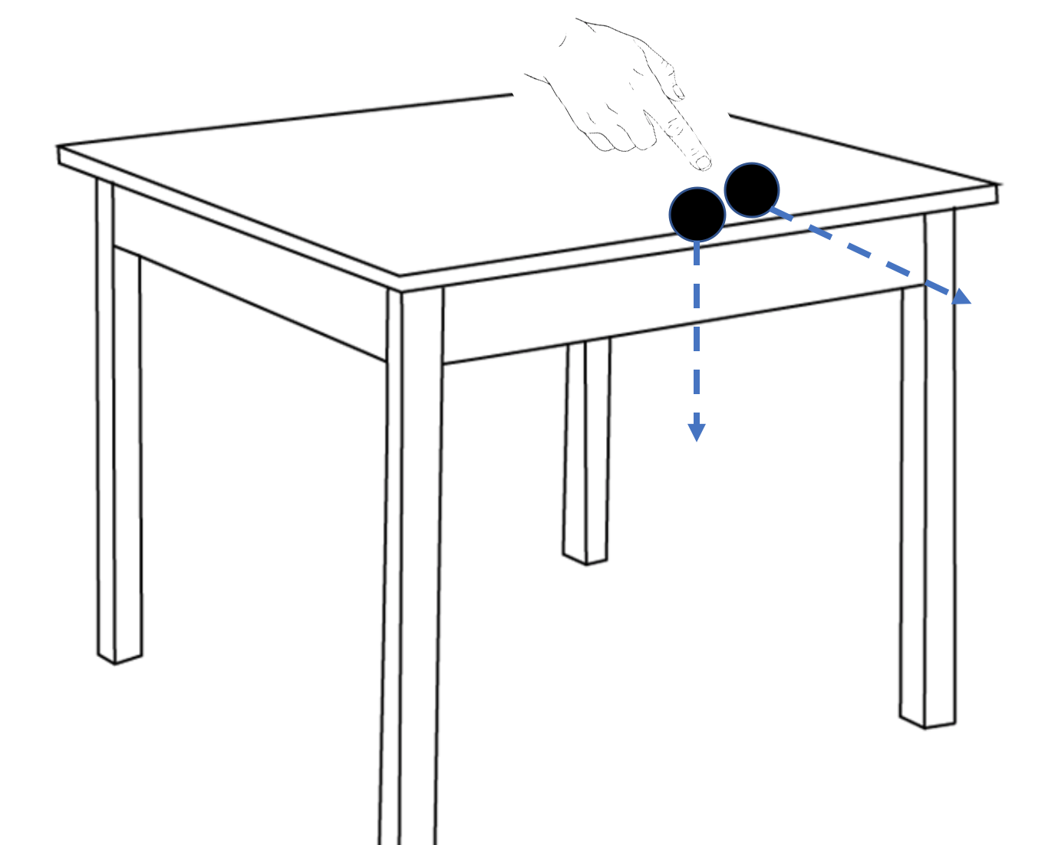

**Results**

1. Carefully study the figure below.

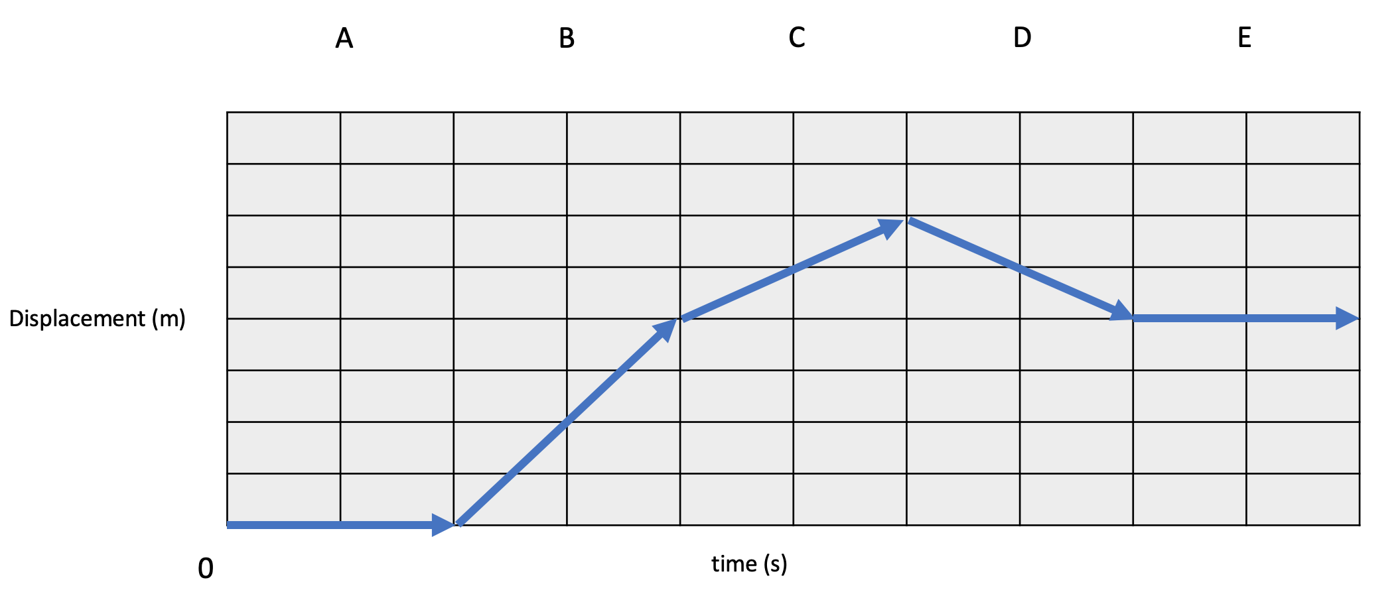

1. Describe the change in velocity of every section.
2. Which section/s the object/s is/are at rest? Why?
3. Which section/s the object/s have maximum magnitude of velocity?
4. Describe the movement of the object in sections C and D. Justify your answer.
5. Suppose 1 ‘box’ in the table represent one unit for displacement and time, what is the total displacement of the object?
6. Carefully study the figure below.

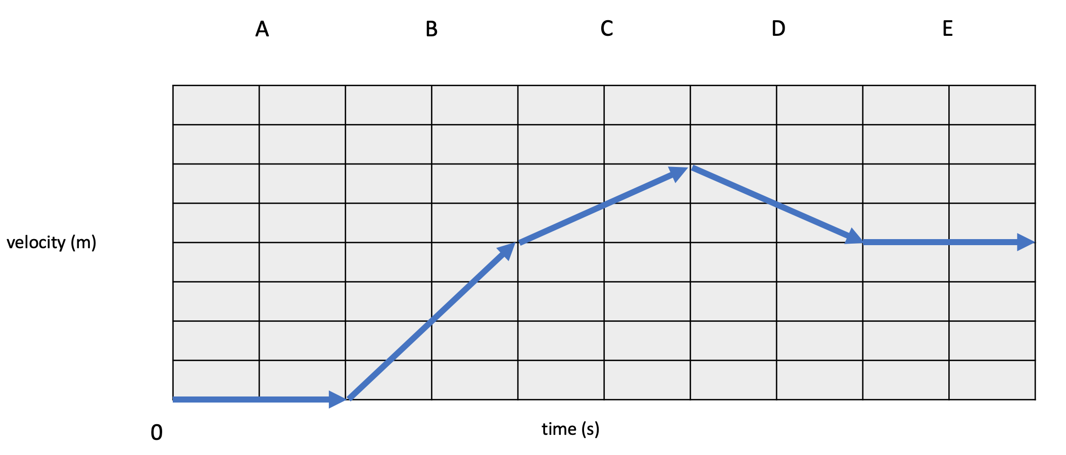

1. At which section/s the object is at rest?
2. At which section/s the object has constant non-zero velocity?
3. At which section/s the velocity is increasing?
4. How do you compare the velocity between sections C and D?
5. Which section/s has the maximum acceleration?
6. Compare the acceleration between sections C and D.
7. Quick experiment:

Questions:

1. How many sounds did you hear when it fell on the floor?
2. Which of the 2 stones fall first?
3. What are the forces acting on each of the stone?
4. Show in a graph the change in velocity of an object in free fall.

**Discussion:**

1. What is shown in a displacement versus time graph?
2. What is shown in a velocity versus time graph?
3. Describe the velocity and acceleration of an object in free fall.

**Conclusion:**

**Reflection:**

How and where specifically you can apply this knowledge?

**References:**